**Course Specialist Test 1 Year 12**

Student name: ________________ Teacher name: ________________

**Task type: Response/Investigation**

**Reading time for this test : 5 mins**

**Working time allowed for this task: 40 mins**

**Number of questions: 7**

**Materials required:** No cals allowed!!

Standard items: Pens (blue/black preferred), pencils (including coloured), sharpener, correction fluid/tape, eraser, ruler, highlighters

Special items: Drawing instruments, templates, notes on one unfolded sheet of   
A4 paper, and up to three calculators approved for use in the WACE examinations

**Marks available: 42 marks**

**Task weighting: 13%**

**Formula sheet provided: no but formulae stated on page 2**

**Note: All part questions worth more than 2 marks require working to obtain full marks.**

**Useful formulae**

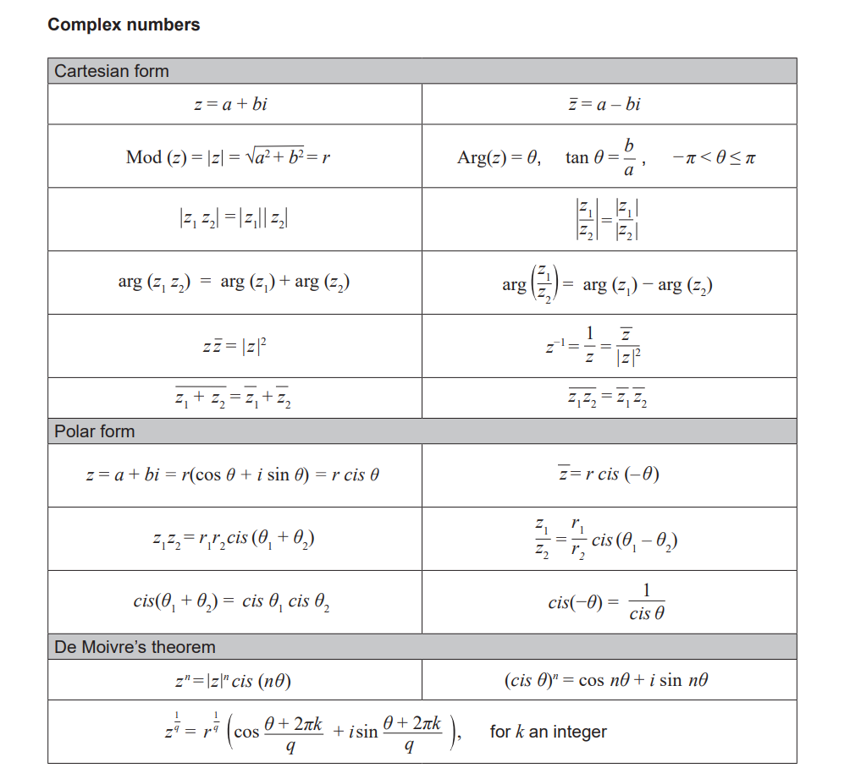



**No cals allowed!!**

Q1 (2, 2, 2 & 2 = 8 marks)

If  and  determine the following exactly.

1. 
2. 
3. 
4. 

Q2 (4 marks)

Determine all possible real number pairs  such that .

Q3 (2, 3 & 3 = 8 marks)

Consider the function .

1. Determine .
2. Hence solve 
3. Consider  where  are real constants and . Determine the values of .

Q4 (3 marks)

Use the diagram below to determine the complex number  in polar form with a principal argument.

(diagram not drawn to scale)

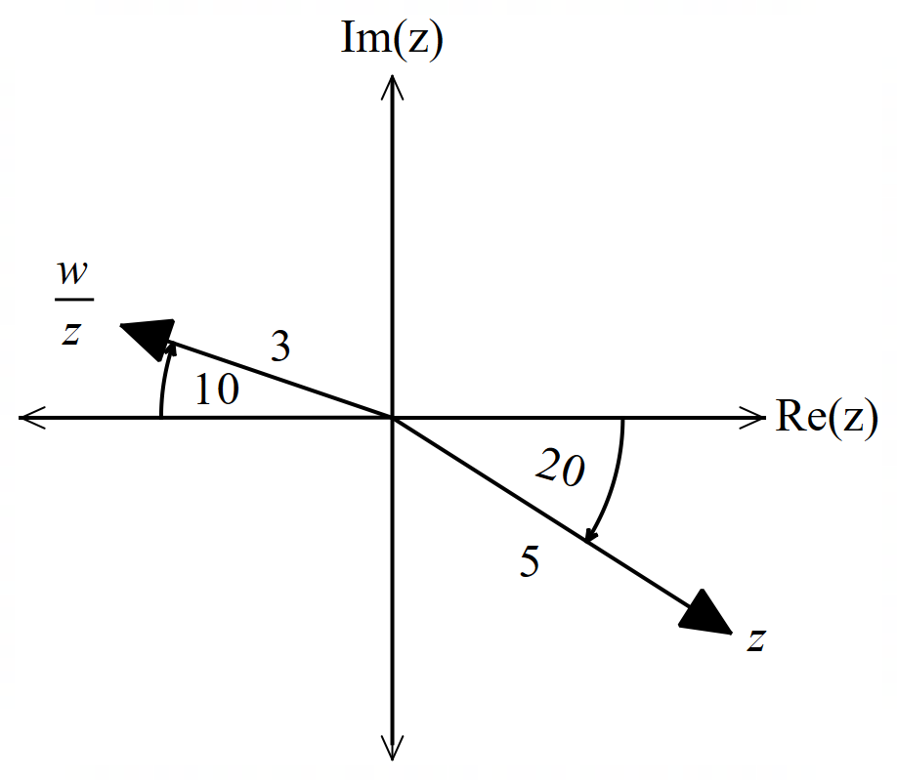



Q5 (2 & 3 = 5 marks)

Sketch the following locus of points on the axes below.

1. 

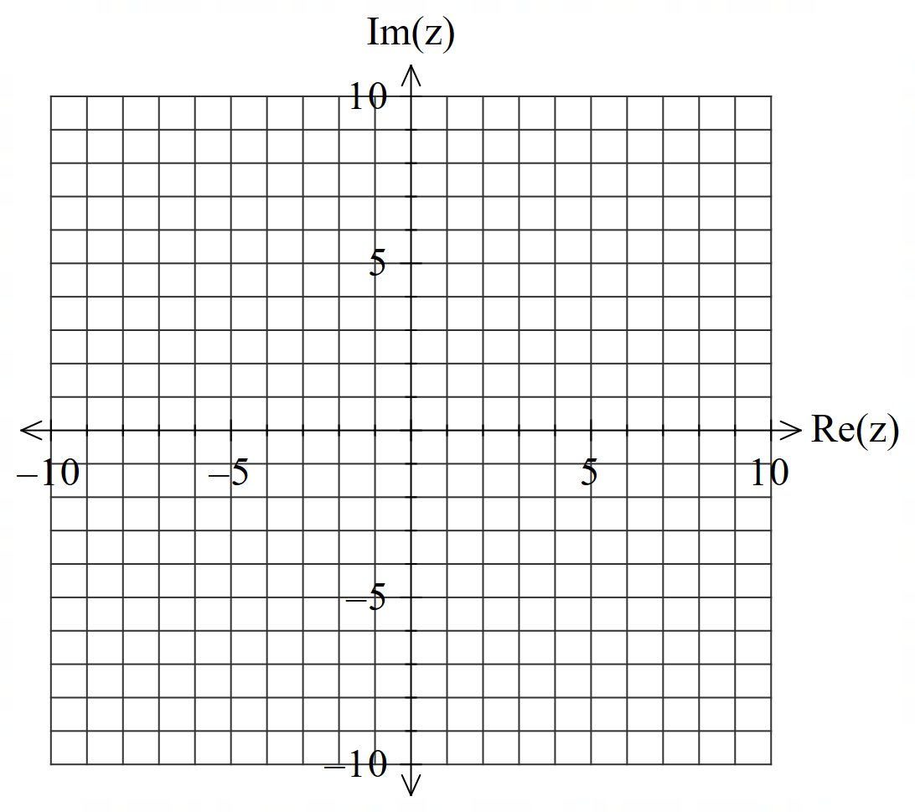

1. 

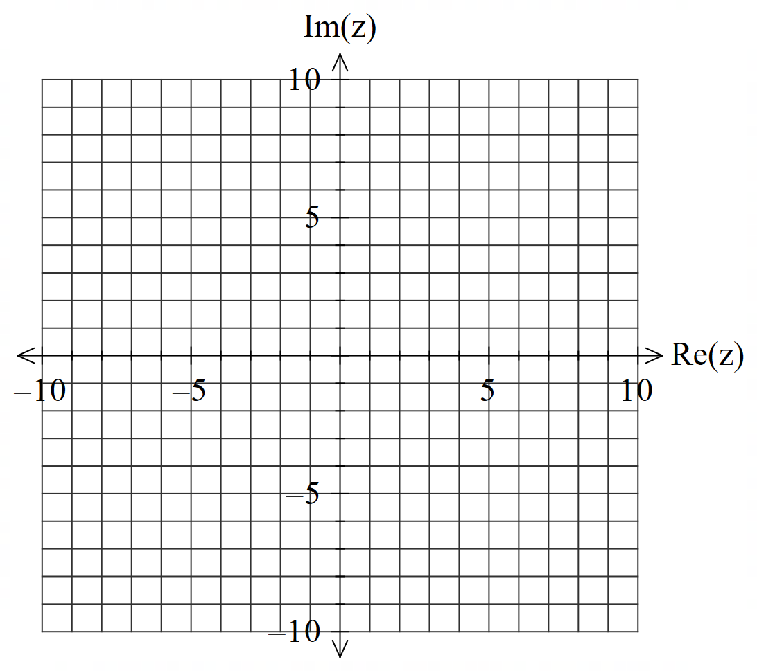

Q6 (5, 2 & 2 = 9 marks)

1. Solve  in polar form with principal arguments.
2. Plot these points on the axes below.

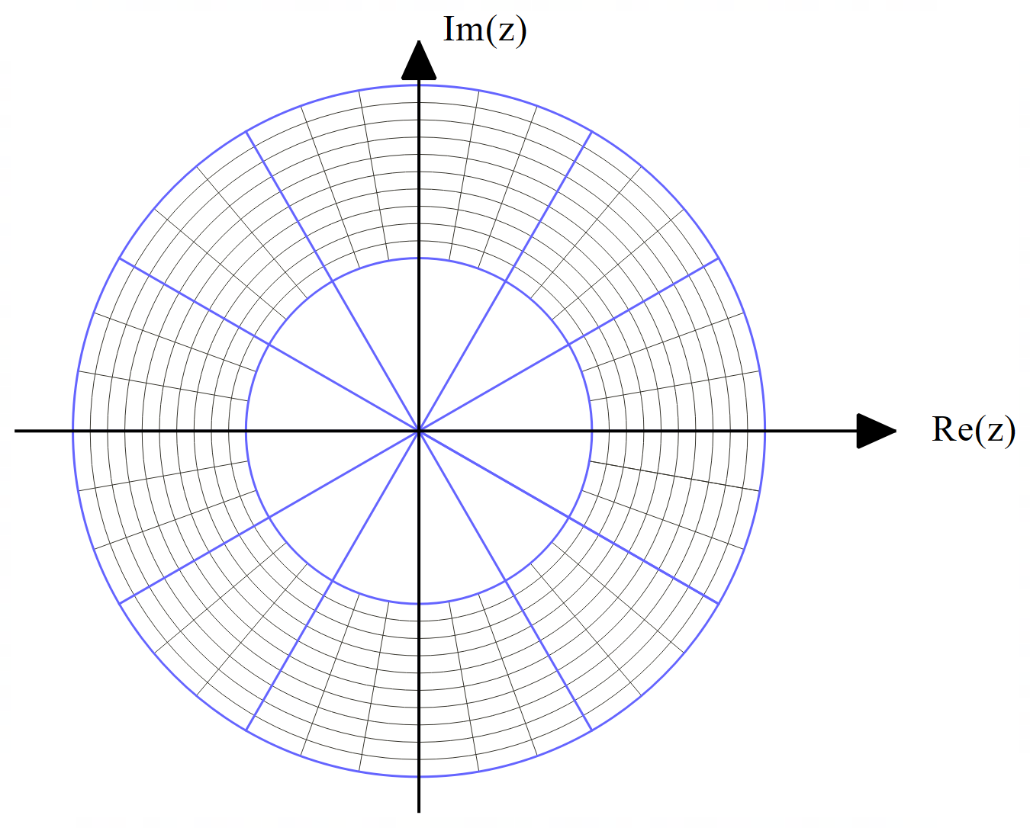

1. Determine the area of the polygon formed by joining the points in (b) above.

Q7 (5 marks)

The locus of  where  are real constants is plotted below and can also be defined as . Determine the values of  showing full reasoning.

(Not drawn to scale)

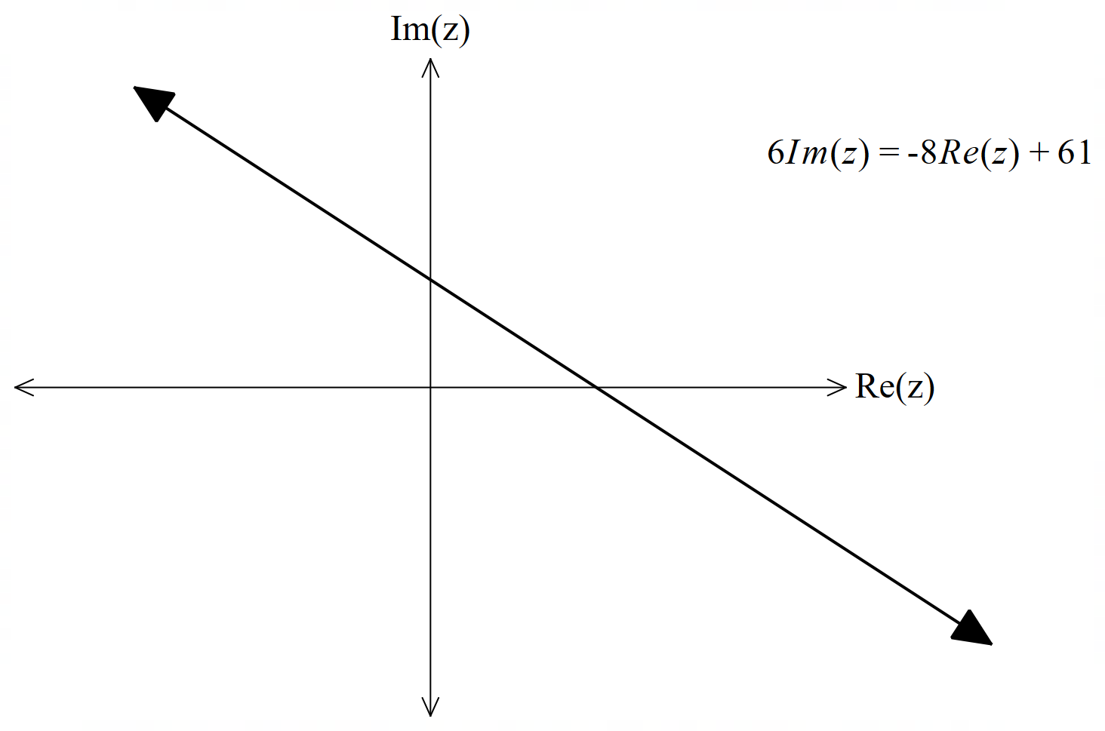

**Working out space**